**Delivery Time Prediction & Clustering Report**

**1. Features Used**

The analysis was conducted using engineered features derived from delivery datasets:

* Distance (Numerical)
* Weather Conditions (Categorical): Cloudy, Rainy, Snowy, Sunny
* Traffic Conditions (Categorical): High, Low, Medium
* Order Time (Categorical): Morning, Afternoon, Evening, Night
* Delivery Category (Categorical): Fast, Medium, Slow

**2. Clustering Analysis**

**2.1 K-Means Clustering**

* Elbow and Silhouette methods were applied to determine the optimal number of clusters.
* Best Silhouette Score: Achieved at **k=10**.
* However, for better interpretability and more meaningful grouping, **k=5** clusters were chosen.

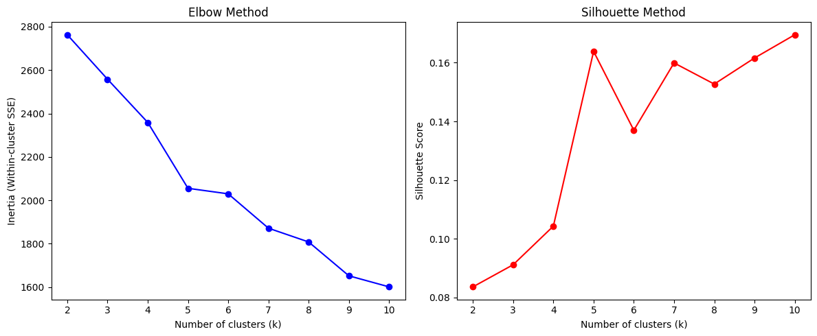

**2.2 Hierarchical Clustering**

* Dendrogram visualisation confirmed natural grouping patterns in the data.
* Cluster alignment with KMeans (Hungarian method) produced a **5×5 aligned confusion matrix**, indicating some overlap and disagreement between the two methods.

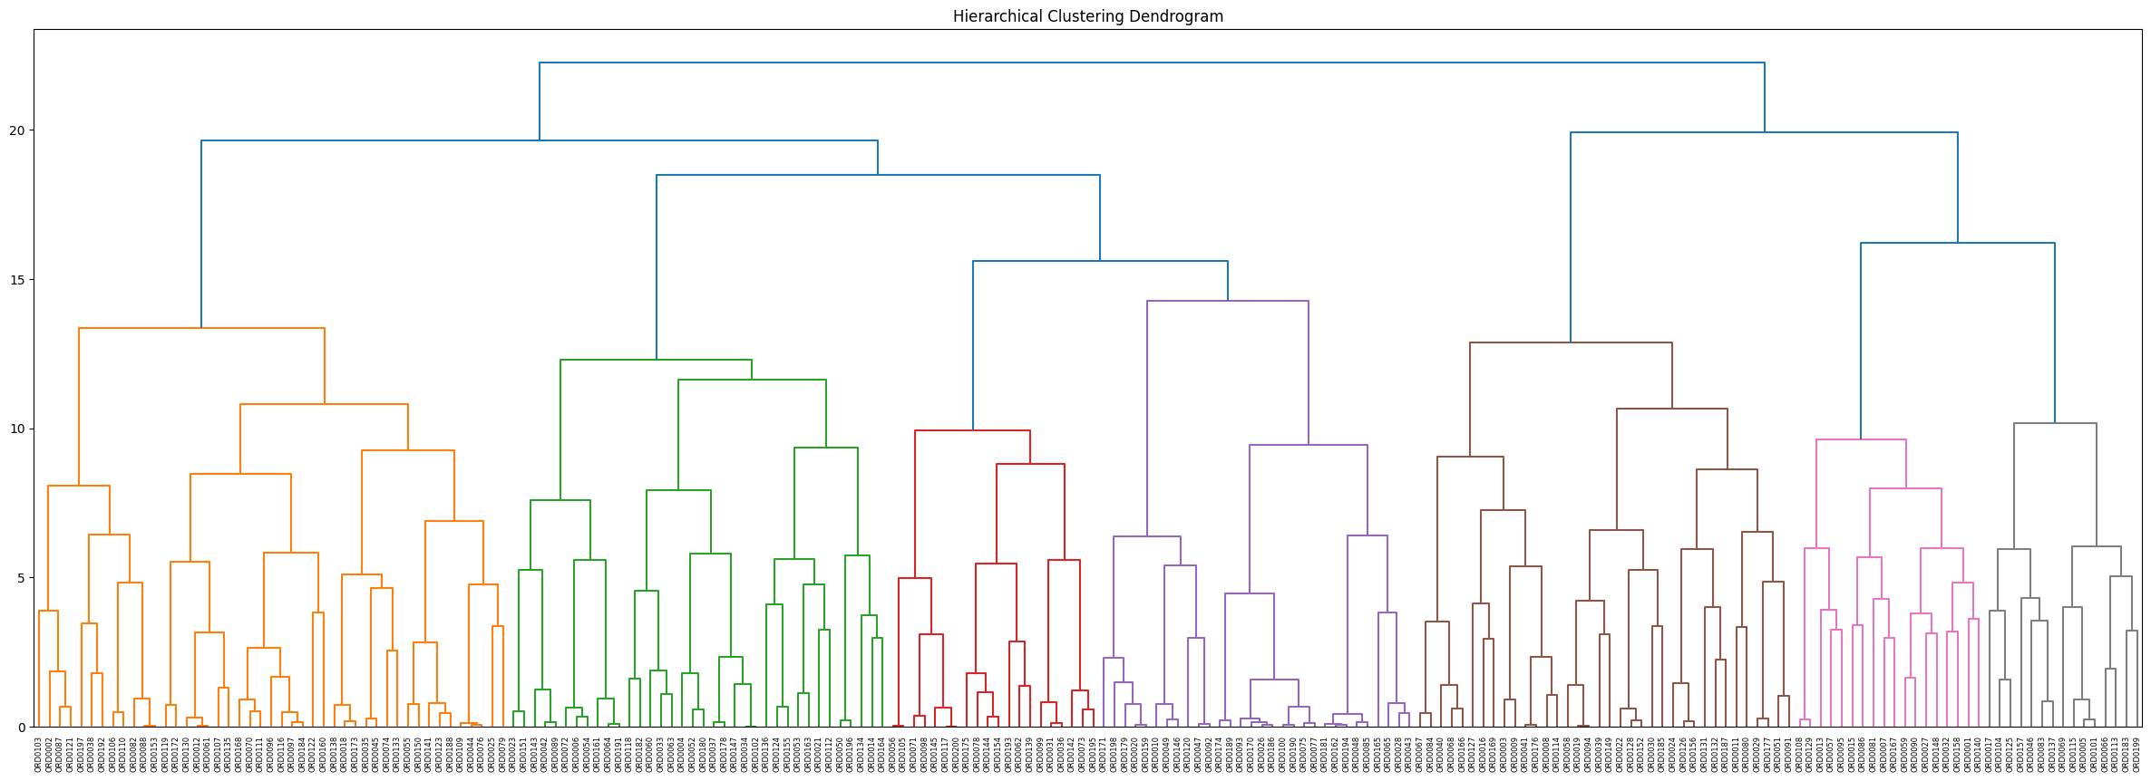

**2.3 KMeans vs Hierarchical (Clustering Agreement)**

* Adjusted Rand Index (ARI): 0.1407 → Low overlap in exact assignments.
* Normalized Mutual Information (NMI): 0.2000 → Weak but non-random agreement in clustering structure.

**Interpretation:**

* Both methods capture different structures in the dataset.
* KMeans produces tighter spherical clusters, while hierarchical clustering finds more imbalanced groupings.
* Clusters align partially, but further refinement of features or dimensionality reduction may improve consistency.

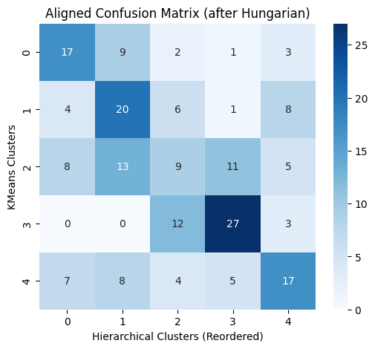

**3. Neural Network Classification**

The target variable was Delivery Category (Fast, Medium, Slow).  
A feed-forward neural network was trained with the following performance on test data:

| **Class** | **Precision** | **Recall** | **F1-Score** | **Support** |
| --- | --- | --- | --- | --- |
| Fast | 0.00 | 0.00 | 0.00 | 5 |
| Medium | 0.00 | 0.00 | 0.00 | 10 |
| Slow | 0.56 | 0.72 | 0.63 | 25 |

* Micro Avg (overall): Precision = 0.53, Recall = 0.45, F1 = 0.49
* Macro Avg: Precision = 0.19, Recall = 0.24, F1 = 0.21
* Weighted Avg: Precision = 0.35, Recall = 0.45, F1 = 0.39
* Accuracy: 45%

**Interpretation:**

* The classifier struggles to predict **Fast** and **Medium** categories (likely due to **class imbalance**).
* Predictions are biased toward the **Slow** category, which has the highest support (25 samples).
* Model improvements could include:
  + Balancing the dataset (SMOTE, weighted loss functions).
  + Hyperparameter tuning (more layers, dropout rates).
  + Feature engineering (time-based encodings, interaction terms).

**4. Key Insights**

1. Clustering:
   * K-Means and Hierarchical clustering produced different structures.
   * A 5-cluster solution was chosen for interpretability despite the silhouette score peaking at k=10.
2. Classification:
   * Neural network performance is modest (45% accuracy).
   * Severe class imbalance impacts the prediction of minority classes (Fast, Medium).
3. Future Work:
   * Improve data preprocessing (balance classes, feature scaling).
   * Try alternative models (Random Forest, Gradient Boosting, CNN/RNN if sequence data available).
   * Use PCA or autoencoders for dimensionality reduction before clustering.

**Conclusion:**  
The current clustering suggests meaningful but imperfect groupings, while the neural network struggles with imbalanced categories. Both methods can be refined further to improve predictive power and interpretability.